**How to Regularize Absence**

1. Log on to <https://www.myatos-syntel.net/>
2. Select Leave and Attendance

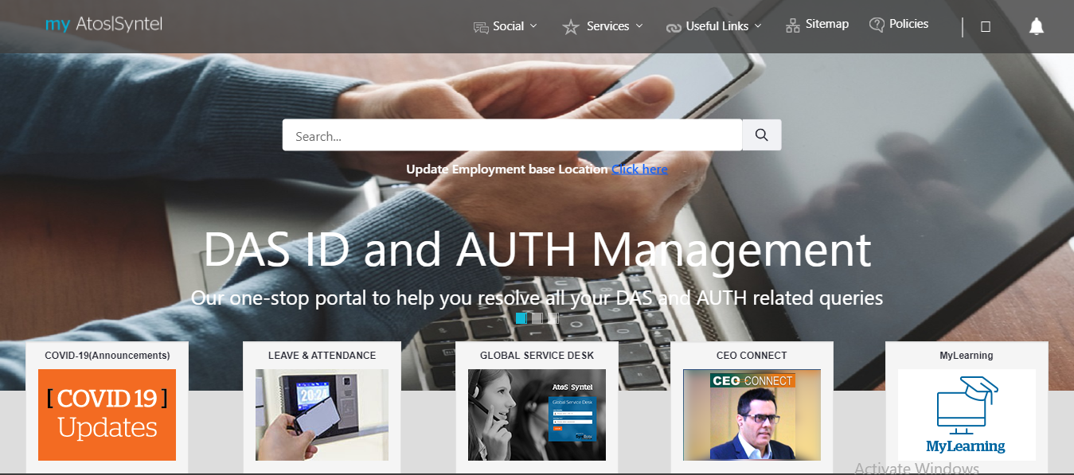

1. Select Click to Continue from Offshore & Other

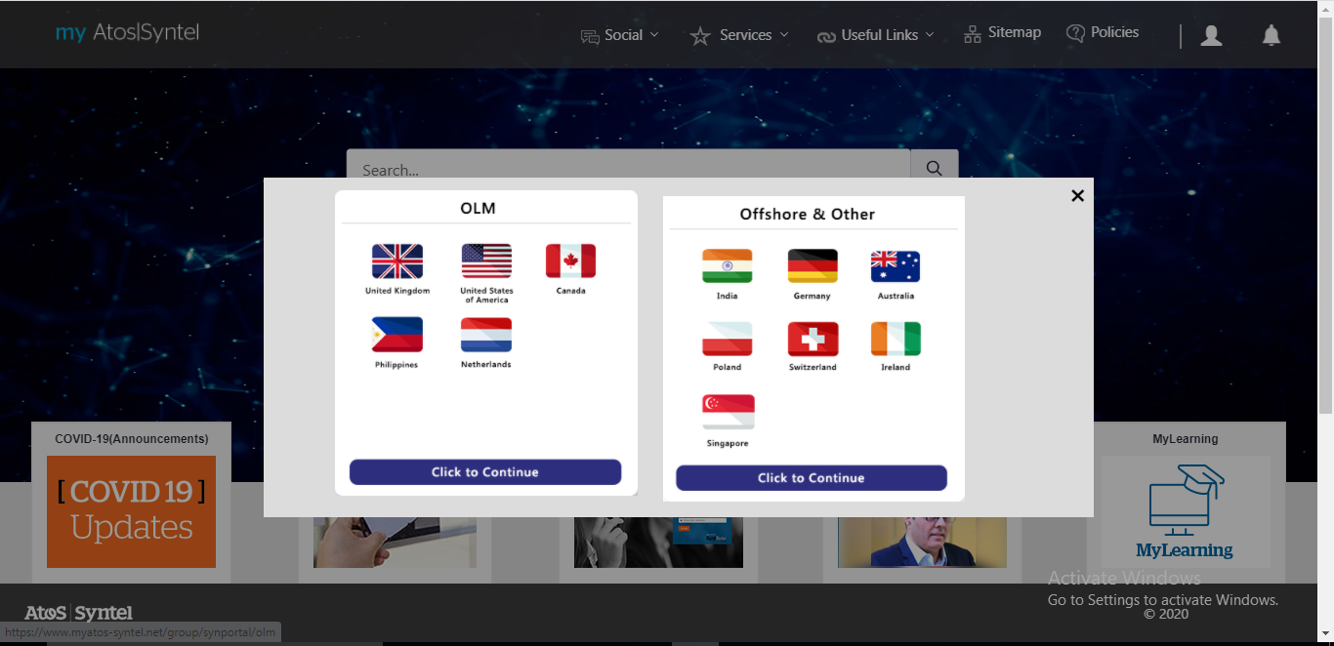

1. Select Absence Regularization

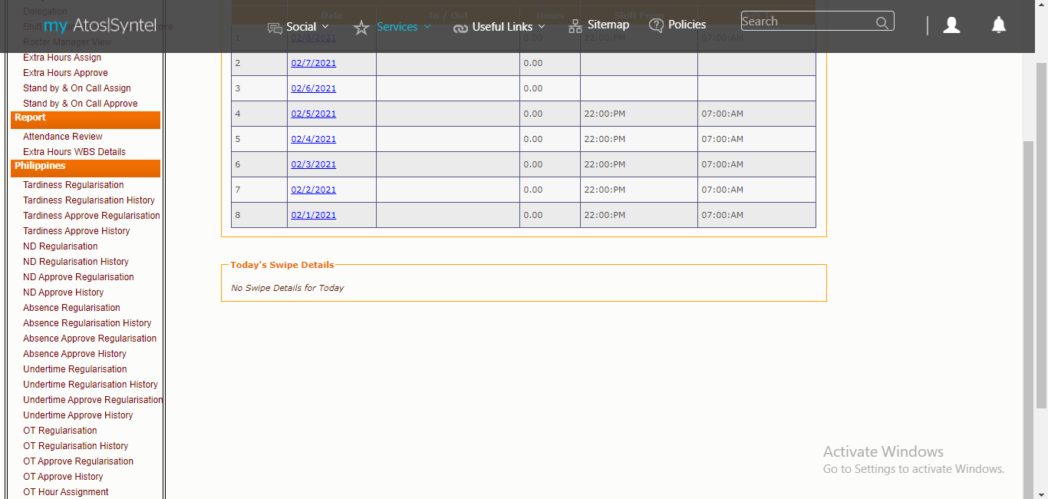

1. Tick the checkboxes that corresponds to the date you want to regularize.

Default value for Reason is WFH-BCP-COVID19

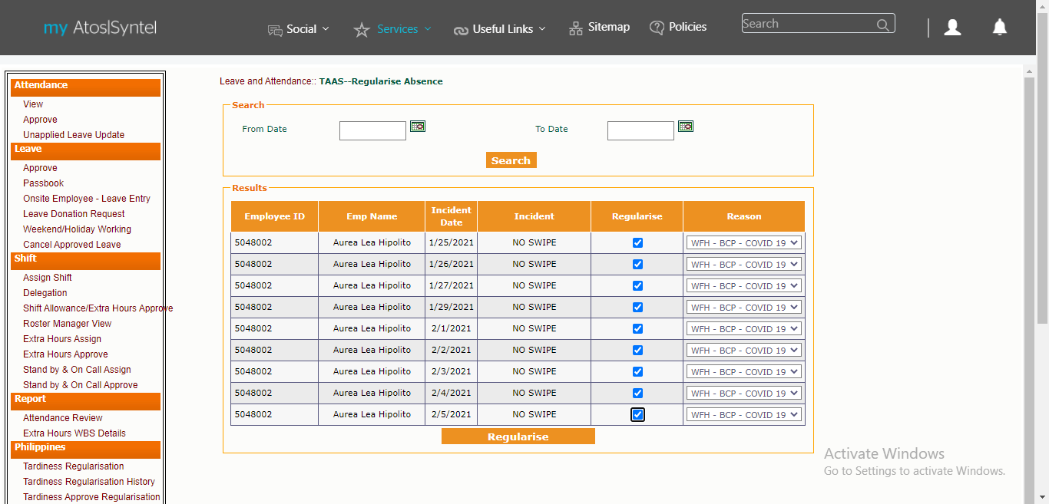

1. Click the Regularize button
2. Click OK

